**IT DEPARTMENT PROCESS**

**EMPLOYEE GRADE REPORT**

1. **Form Design**
2. **Work Order Description**
3. **Table Name**
4. **Conditions**

**Work Order Year: 2018-19**

**No: INTERNAL Created By: Kamatchi G**

**1. FORM DESIGN**

**1.1 Customer Home Page View:**

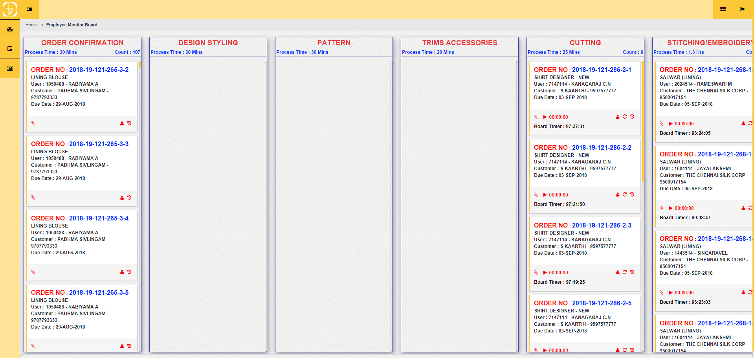

**1.2 Assign User View:**

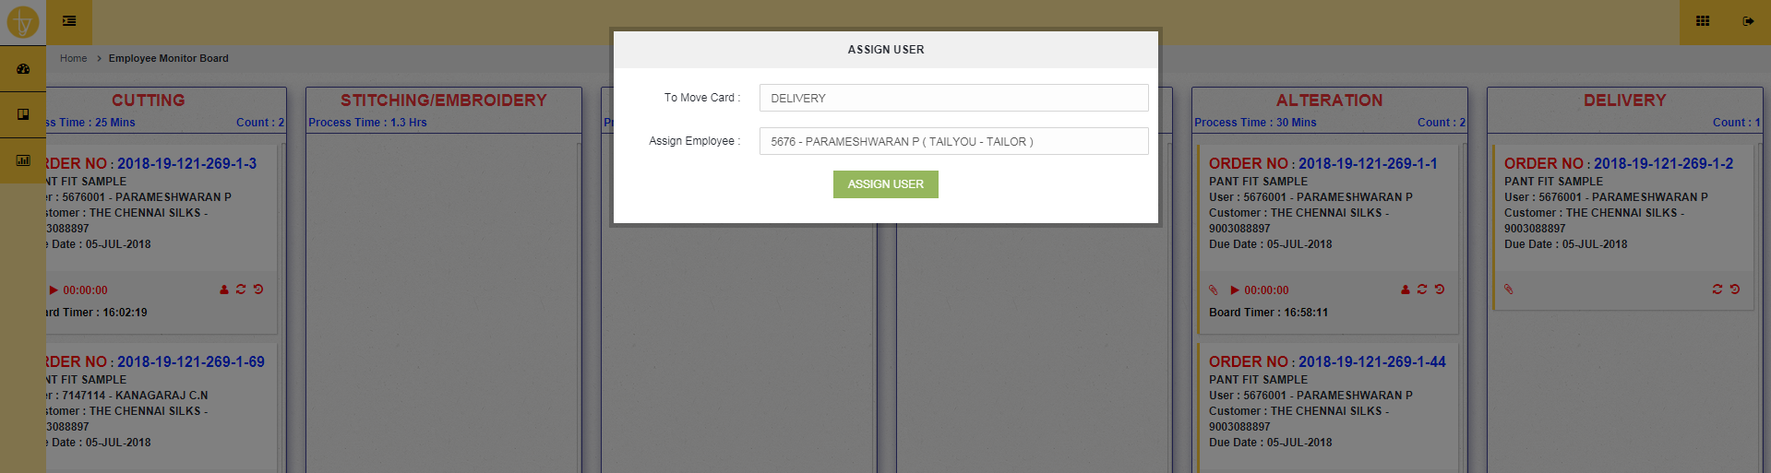

**1.3 Work Order History View:**

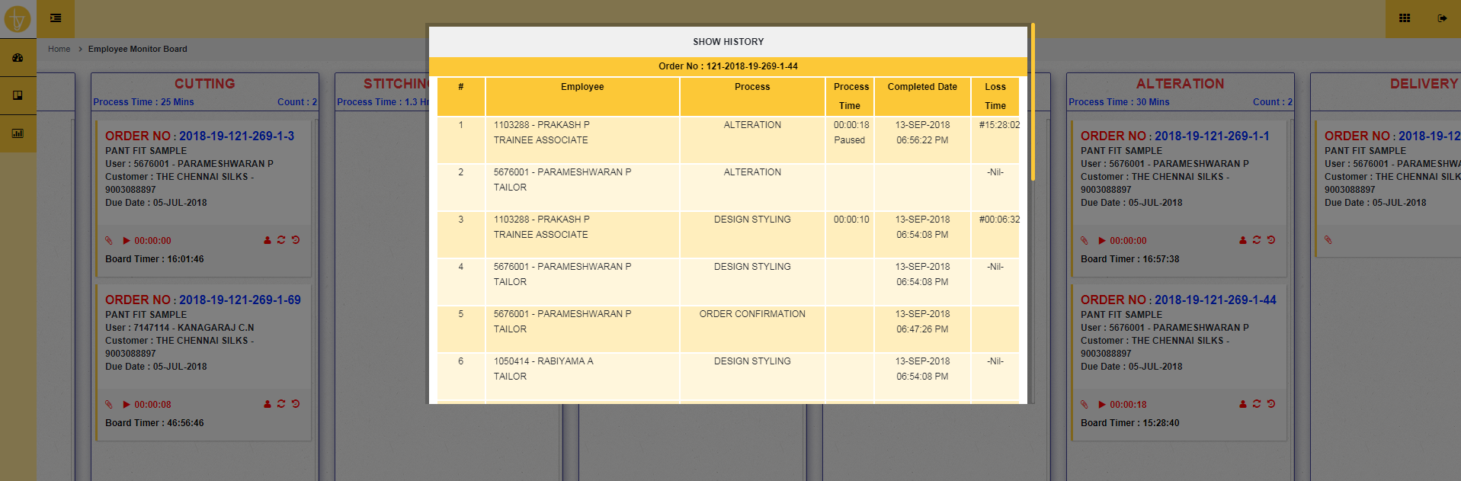

1. **DESCRIPTION**

The page is used to monitor to all order process stage by stage. Each panel displayed No.of orders and customer details and work order person details. And some advanced feature like assign work to other person, enable timer for each work order, board Timer, revert the work order stages and displaying the history of orders by stage by stage with process time and loss time. And final stage of Delivery is used to display all completed orders ready to delivery.

**TABLE NAME**

**3.1 Main Table:**

* Employee_Grade_Fix
* Employee_Head_User

**3.2 Reference Tables:**

* + - Employee_office

**4. CONDITIONS**

* + - 1. DELETED = ‘N’
      2. TIMRMOD = 1-Board timer
      3. TIMRMOD = 2- Manual Timer
      4. DELETED =’P’ –Timer Paused